Consultation Feedback Analysis
Millbrook Solar & Storage – consultations #1 to #3
Tom Berger · 02 October 2026 · WE-CE-RPT-2026-07

1. Summary
Across three public consultations (2026-03-11, 2026-05-20, 2026-09-16) 563 people attended and we received 472 written responses. The three most raised themes overall were construction traffic on mill lane (174 mentions), support for local clean energy (158) and glare for nearby homes (128).
Support among respondents rose from 42 % to 53 %, and opposition fell from 37 % to 29 %. The changes that made the biggest difference, judging from the comments, were the haul road from the B4127, removing field 7 and the community fund.

2. Participation
Event | Date | Venue | Attendees | Responses
#1 | 2026-03-11 | Millbrook Village Hall | 164 | 97
#2 | 2026-05-20 | Millbrook Village Hall | 212 | 202
#3 | 2026-09-16 | St Mary's Church Rooms, Millbrook | 187 | 173
Total |  |  | 563 | 472

3. Themes
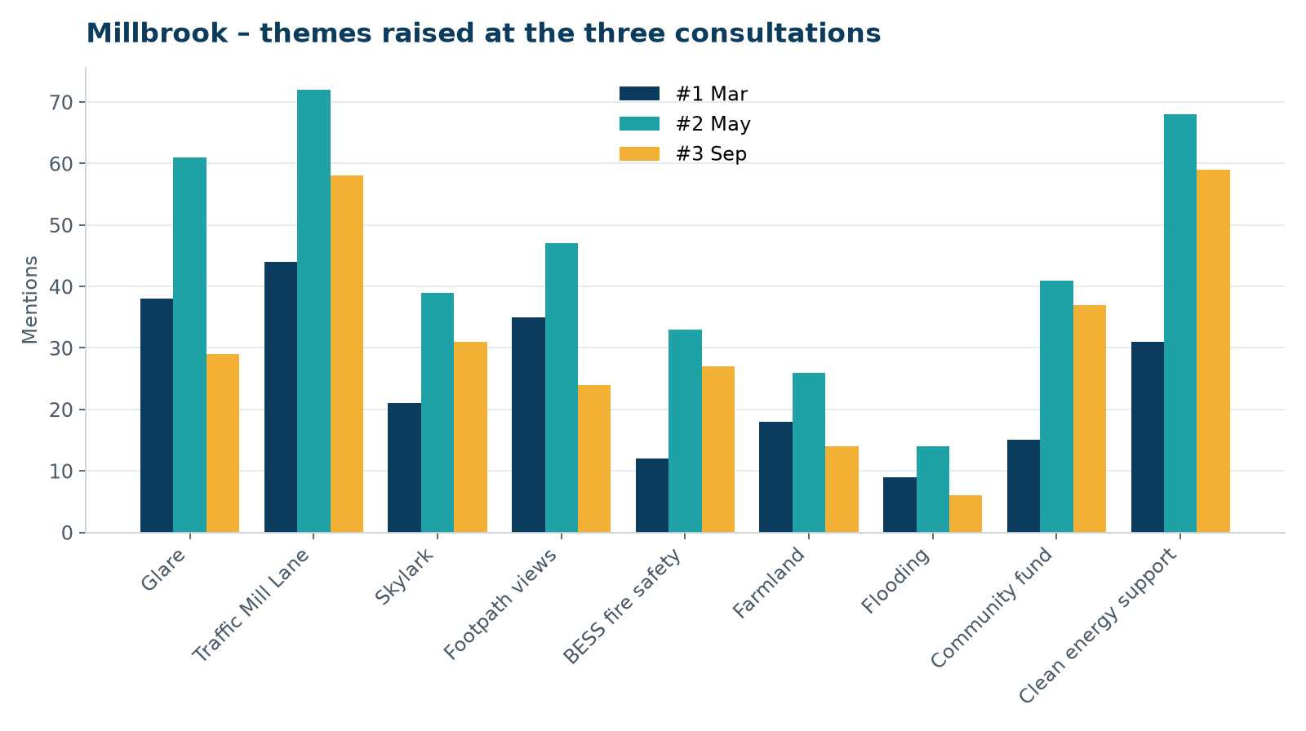
Mentions per theme and consultation (a response may raise up to two themes)
Theme | #1 | #2 | #3 | Trend
Glare for nearby homes | 38 | 61 | 29 | falling
Construction traffic on Mill Lane | 44 | 72 | 58 | stable
Skylark nesting habitat | 21 | 39 | 31 | stable
Visual impact from the public footpath | 35 | 47 | 24 | falling
BESS fire safety | 12 | 33 | 27 | stable
Loss of farmland / food production | 18 | 26 | 14 | falling
Flood risk on Mill Brook | 9 | 14 | 6 | falling
Community fund and local benefit | 15 | 41 | 37 | stable
Support for local clean energy | 31 | 68 | 59 | stable

3.1 Construction traffic on Mill Lane
Still the most frequently raised concern at #3 (58 mentions), but the tone changed: most comments now ask for enforcement of the CTMP ("who will check the lorries don't come through the village?") rather than rejecting the scheme. We propose a public HGV log and a named contact during construction.

3.2 Glare for nearby homes
Mentions fell from 61 to 29 after the glint and glare study was published. Remaining concerns come almost entirely from residents of Mill Lane Cottages, who want the 3 m hedgerow height secured by condition – now proposed.

3.3 Skylark nesting habitat
Fairly stable (39 → 31). The local RSPB group asked for the monitoring results to be published; we agreed.

3.4 Battery fire safety
Rose sharply between #1 and #2 after national press coverage of a battery fire abroad. The fire service's review of the BSMP was well received at #3.

4. Sentiment
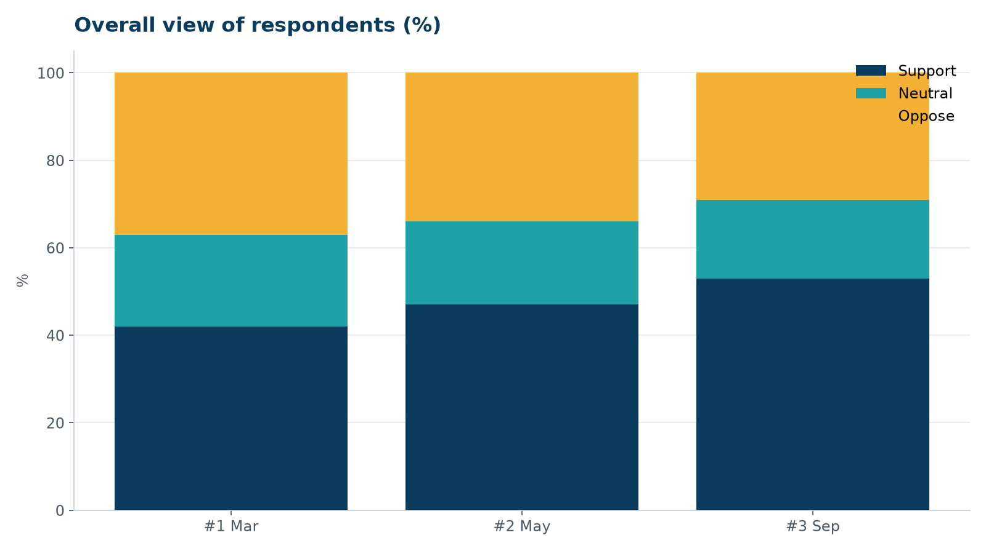
Support, neutral and oppose shares by consultation

5. Recommendations
- Publish a monthly HGV log during construction and set up a construction hotline.
- Share skylark monitoring reports with the RSPB group and the parish council.
- Hold a community fund workshop in early 2027, before the planning committee.
- Keep the Community Liaison Group running through construction.
Numbers for consultation #3 are final as of 2 October (feedback window closed 30 September).

